Amplitude amplification is the central quantum trick behind Grover’s algorithm. It’s a method to take a quantum state that has small amplitude on “good” (marked) solutions and amplify those amplitudes so a measurement finds a good solution with high probability.

1) The big picture (intuitive)
- Prepare a superposition of all possible candidates (e.g. |ψ₀⟩ = (1/√N) ∑ |x⟩).
- Some of those basis states are “good” (marked by the oracle). Initially each good state has tiny amplitude.
- Use an oracle that marks good states (by flipping their phase).
- Use a “diffusion” (inversion-about-the-mean) operator that reflects the state about the average amplitude.
- Repeating “oracle → diffusion” repeatedly causes the amplitudes of good states to grow (and bad states shrink) — that’s amplitude amplification.
Think: the algorithm rotates the state vector in a 2D subspace toward the good-subspace. After the right number of iterations, measure and you get a marked item with high probability.

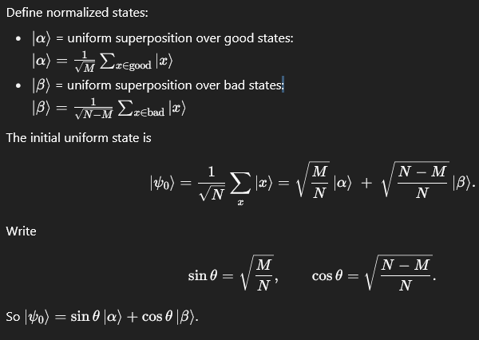

3) Operators used
- Oracle $O$: flips phase of good states:
$$O∣x⟩=(-1)^{f(x)}∣x⟩,$$
where $f(x)=1$for good states. In the $\{∣α⟩,∣β⟩\}$basis, $O$acts like a reflection that multiplies $∣α⟩$by $-1$and leaves $∣β⟩$unchanged.
- Diffusion (Grover) operator $D$: inversion about the mean:
$$D=2∣ψ_{0}⟩⟨ψ_{0}∣-I.$$
This reflects states about the vector $∣ψ_{0}⟩$.
- One iteration of amplitude amplification is:
$$G=D⋅O$$
(applying oracle then diffusion).

4) Geometric (2D rotation) picture
In the 2D plane spanned by $∣α⟩$and $∣β⟩$, the operator $G$is a rotation by angle $2θ$:
$$G(∣ψ⟩)=R(2θ) ∣ψ⟩,$$
where initially $∣ψ_{0}⟩$is at angle $θ$from the $∣β⟩$-axis (or at angle $θ$above $∣β⟩$). After $k$iterations:
$$∣ψ_{k}⟩=sin⁡((2k+1)θ) ∣α⟩+cos⁡((2k+1)θ) ∣β⟩.$$
So amplitude on good subspace is $sin⁡((2k+1)θ)$. We want that to be ≈1.

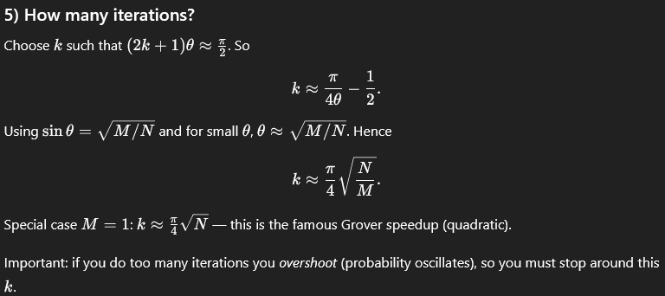
6) Numeric example (N=8, M=1)
- $N=8$, one marked state → $sin⁡θ=\sqrt{1/8}≈0.3536$
- Required iterations: $k≈(π/4)/θ≈2.175$→ round to 2 iterations.
- Start: amplitude on good = $sin⁡θ≈0.3536$⇒ prob ≈ 0.125.
- After 1 iteration: amplitude = $sin⁡(3θ)≈sin⁡(1.0842)≈0.884$⇒ prob ≈ 0.781.
- After 2 iterations: amplitude = $sin⁡(5θ)≈sin⁡(1.8068)≈0.973$⇒ prob ≈ 0.947.
- After 3 iterations: amplitude = $sin⁡(7θ)≈sin⁡(2.5296)≈0.574$⇒ prob ≈ 0.330 (overshot).
So 2 iterations is best here.
7) Circuit sketch (how to implement)
A practical amplitude amplification (Grover) step for one iteration:
- Prepare $∣ψ_{0}⟩$= H on all input qubits (uniform superposition).
- Oracle $O$: implement as phase flip on marked states (usually by some controlled gates that flip target phase).
- Diffusion $D$: implement as
  - H on all qubits
  - X on all qubits
  - multi-controlled Z (phase flip on |00...0⟩) — can be implemented with ancillae or by starting with an ancilla prepared and using multi-controlled Toffoli to flip a phase
  - X on all qubits
  - H on all qubits
So circuit for one G = (H X ... multi Z ... X H) · O.
8) Generalizations & variations
- Multiple solutions (M>1): amplitude amplification still works; use $k≈\frac{π}{4}\sqrt{N/M}$
- • Amplitude amplification as a subroutine: it’s a building block for amplitude estimation, quantum counting, and more.
- • Exact Grover: If you know $M$exactly, you can choose a fractional number of iterations or slightly adjust phases to get exact success probability 1.
- • Quantum amplitude estimation uses amplitude amplification inside a phase-estimation-like routine to estimate the amplitude instead of amplifying it fully.
9) Why it works (short math reason)
- Oracle $O$is a reflection about the good-subspace (flips sign of the good component).
- Diffusion $D$is reflection about the initial state $∣ψ_{0}⟩$.
- Composition of two reflections = rotation. Repeated rotations move the state closer to $∣α⟩$.
Formally: two reflections $R_{u}$and $R_{v}$produce a rotation by twice the angle between the reflection axes.
10) Practical considerations & pitfalls
- Overshooting: do not run too many iterations; success probability oscillates.
- Unknown M: if you don’t know M, you can use quantum counting or adaptive strategies (run different numbers of iterations and check).
- Noise & errors: real hardware noise reduces the benefit; fewer iterations preferred on noisy devices.
- Oracle cost: cost to implement oracle matters — speedup counts total cost, not only query count.
- Multi-controlled gates cost: diffusion uses multi-controlled operations which can be expensive on real devices.
11) Visual summary (short)
- Prepare uniform superposition.
- Repeat k times:
  - Oracle: flip phase of good states.
  - Diffusion: invert about mean.
- Measure → with high probability you get a good solution.
k ≈ (π/4)√(N/M).

Step 1: What is Amplitude Amplification?
Think of a quantum state as a list of possibilities, each with a small amplitude (like “chance weight”).
Amplitude amplification increases the amplitude (probability) of the “correct” (good) states.
Classically, to find one correct answer among $N$possibilities you might need $O(N)$tries.
Quantumly, amplitude amplification finds it in about $O(\sqrt{N})$
Step 2: The Math (simplified)
Let $N$= total number of possibilities.
Let $M$= number of correct (good) solutions.
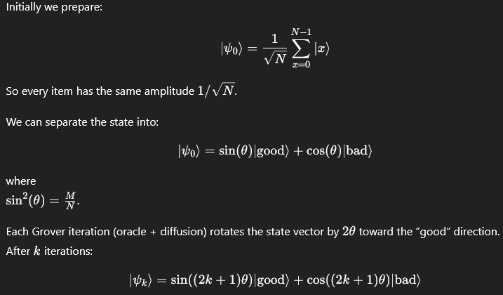
To maximize the probability of measuring a good state:
$$(2k+1)θ≈\frac{π}{2}⇒k≈\frac{π}{4θ}-\frac{1}{2}≈\frac{π}{4}\sqrt{\frac{N}{M}}.$$Step 3: Example with Small Numbers
Say we have $N=4$states: 00, 01, 10, 11.
Suppose only 11 is the correct answer ($M=1$).
Then $sin⁡(θ)=1/2$→ $θ=π/6$.
So one Grover iteration rotates by $2θ=π/3$.
After one iteration:
$(2k+1)θ=3θ=π/2$→ success probability ≈ 1.
In this small case, only one iteration is needed.

Concept | Explanation

Superposition | Start with all states equally probable

Oracle | Flips the phase of the good state

Diffusion | Reflects amplitudes about their average (inverts phase of average)

Iteration | Each step rotates amplitude toward the good state

Measurement | Reveals the good state with high probability
Simple Visualization (Geometric Intuition)
Amplitude amplification = rotation in 2D space
between “good” and “bad” components.
Each iteration:
- Oracle = reflect about the good axis
- Diffusion = reflect about the average state
- Two reflections = one rotation
→ That’s why the amplitude of the good state grows!

